2018考研英语（一）真题大作文范文—选课进行时
来源：文都教育
2018考研英语已经结束，文都老师及时为同学们整理了本次考试的真题，先给大家带来的是英语（一）大作文。本次作文题目是“选课进行时”，跟同学们的学习很贴近，难度应该不算太大，下面是文都老师给同学们提供的一篇范文，供大家学习欣赏。

Directions:
Write an essay of 160-200 words based on the picture below. In your essay, you should
- describe the picture briefly
- interpret the meaning, and
- give your comments.
Write your answer neatly on the ANSWER SHEET.(20 points)

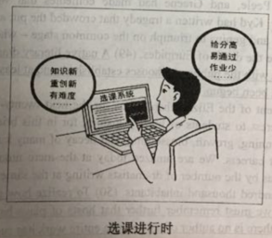
参考范文：
As is depicted by the picture, a student is selecting courses. He is considering whether to choose the courses which are high scored, easily passed with less homework, or to choose those that contain new knowledge, focus on creating and are difficult to learn. From my perspective, I will choose the latter ones. The reasons are as follows.
The college students are faced with fierce competition in nowadays. Those courses which are full of advanced knowledge can broaden our horizon and enrich our knowledge. More over, they pay more attention to creativity so that I can be equipped with novel viewpoints in the future when seeking a job, which can help me become more competitive among the peers. Last but not least, to learn those courses which are difficult can give me a sense of accomplishment.
We young people are the hope of our country, and we must study hard to become the future star of our country!

