2019年6月英语六级翻译模板：图书分两类
来源：文都教育
英语六级翻译模板：图书分两类
尽管图书的种类多种多样，但从本质上说，它们都可以被分为 两大类,即纪实题材(fact)与小说题材。有时二者之间很难辨别，因 为许多小说都是围绕着(mixed)现实事件和真实人物来进行创作的。 纪实题材的书籍包括:历史书，教科书，旅行手记，手册指南(manual) 和自传(autobiography)等。
六级翻译模板参考：
There are many, many different types of books but, essentially, fliey come in two categories, fact or fiction. Sometimes it is hard to distinguish between the two, because some fiction stories are mixed around true event and refer to real life people. The types of books that are included in the factual category are history books, text books, travel books, manuals and autobiographies.
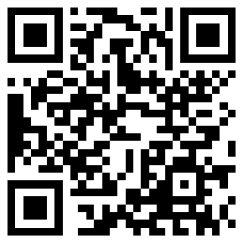
扫码文都四六级网，手机轻松复习备考

