2019年12月英语六级作文模板(3)
来源：文都教育
现在社会，随着经济快速发展，人们的物质欲望愈发膨胀。一切向钱看，成了一种不约而同的心理暗示。于是，人际关系越来越紧张，人们为了物质勾心斗角，但是，金钱真的就这么的高于一切。
英语六级作文题目：
How Important Is Money?
金钱有多重要?
英语六级作文参考范文：
No one would argue, I think, that money is unimportant. There are certain things that human beings need — food, shelter, medical care and these things cost money. But if one has enough money to live on, to pay for the basic essentials of life, is it important to have a lot more money than that? Will your life improve in proportion to the amount of money that you have?
Well, there is no denying that money can buy a lot. Maybe you do not need much money to pay for a simple shelter, but how about if you want a nice big apartment in a nice neighbourhood, or if you want to buy a house? In fact, people do get on each other's nerves if they are crowded together in a small kitchen, if a married couple cannot but share a room with their parents, if children are not allowed to have a little privacy of their own.
Moreover, it is nice to get a little pleasure out of life, a little fun from time to time. Unfortunately, many of the fun things that you can do today cost money. In modern cities, for example, on any night, outstanding performers appear in night clubs and on concert stages. Furthermore, you can dine on foods from every corner of the world in the restaurants. So how can it be that many people in modern cities do not have fun? Simple, they do not have the money to take advantage of all these attractions.
So, is money the road to happiness? Not really. Large numbers of people work every day, work overtime, work weekends, and make a lot of money. Are they happy? No. They have no time to form or maintain friendship, no time to enjoy themselves.
Surely everyone has thought at times, "If only I had a lot of money, I would be the happiest person in the world." But it is important to remember that money is only a means to an end, not the end itself.
以上就是2019年12月英语六级作文模板(3)，同学们有时间一定要练习一下哦！只有广泛涉猎，每种类型的作文题材都接触到了，在考试中才不用担心会为作文绞尽脑汁。更多备考信息，请关注文都四六级网站。
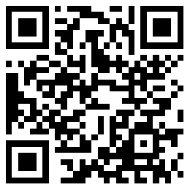
扫码文都四六级网，手机轻松复习备考

