2019.12英语六级翻译范文：文房四宝
来源：文都教育
四六级考试与文学类作品翻译不同,考试要求考生能够忠实且准确地译出原文,并不需要使用华丽的语言及修辞,因此考生能努力做到“信”和“达"即可。今天文都四六级网站为大家分享2019年12月英语六级翻译范文：文房四宝，希望对您有所帮助。
12月英语六级翻译范文：文房四宝
文房四宝(Four Treasures of the Study)是中国书法传统书写工具的统称，包括笔、墨、纸、砚(inkstone)。“文房”指的是学者的书房。除了这四宝，书房里的工具还有笔筒、笔架、墨盒、腕托、笔洗、墨块(inkpad)，这些都是书房必备品。唐宋是书法的繁荣时期，当时著名的生厂商制造的经典文房四宝被后世学者高度赞扬。中国传统文化及艺术的发明和发展与文房四宝密切相关。在某种程度上，文房四宝代表了中国传统文化的重要元素。
六级翻译参考译文：
The Four Treasures of the Study,is a general name of the traditional writing tools of Chinese calligraphy, including writing brush, ink, paper and inkstone. The name of Wenfang refers to a scholar's study. Besides these four treasures, tools used in the study also include brush pots, brush rack,ink box, wrist-rest, brush washer and inkpad, all of which are necessities of the study. Classical products of the Four Treasures of the Study made by famous producers during the Tang and Song Dynasties, when styles of writing were very prosperous, were highly praised by later scholars.The invention and development of China's traditional culture and art are closely related to the Four Treasures of the Study.And to some extent,the Four Treasures of the Study represents an important element of traditional Chinese culture.
今天文都四六级向大家分享的2019年12月英语六级翻译练习：文房四宝。想要了解更多六级翻译技巧和方法，请大家关注文都四六级，老师会随时为大家分享相关信息，同时也预祝大家在这次考试中取得好成绩。
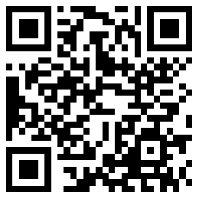
扫码文都四六级网，手机轻松复习备考

