2019.12月英语四级范文模板：改正坏习惯来源：文都教育
今天文都四六级为大家分享2019.12月英语四级范文模板：改正坏习惯，满满的干货，只要你认真用心的学，就能取得好成绩!更多英语四级范文，英语四级写作技巧，英语四级作文范文请及时关注文都四六级网站。
12月英语四级范文模板：改正坏习惯
四级写作范文参考：
Certainly, every person has bad habits. Some people may be in the habit of speaking rudely; some tend to be deaf to others' opinions; some are inclined to delay. However, there is no doubt that allowing to be controlled by bad habits does a great harm to personal development.
It is not too much to say that it is a destructive behavior to allow to be controlled by bad habits while it is constructive to change unwanted habits. If bad habits are allowed to be developed, they will get out of control and become big obstacles to life or career. For example, a delayed-prone person will hardly restrain himself from missing the deadline. Understandably, he will have few chances to be entrusted with important tasks and then will barely be professionally experienced enough to gain promotion. On the contrary, it is beneficial to change unwanted habits and acquire good ones, because good habits can make people more competent and thus widen the door to success.
In summary, bad habits will probably make it impossible for us to achieve our ambitions. Therefore, we should be alert to our bad habits and make persistent efforts to break them.
以上就是文都四六级分享的2019.12月英语四级范文模板，希望参加考试的同学参考一下，最后希望大家都能顺利通过本次考试!
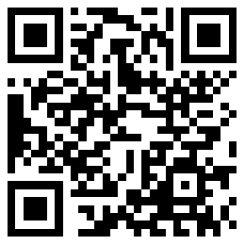
扫码文都四六级网，手机轻松复习备考

