2020年6月大学英语四级翻译练习：《西游记》
来源：文都教育
翻译模块作为四级考试中相对不好复习的一个模块，许多考生每每提及这个模块，都是一种又爱又恨。许多考生甚至会出现这样的误区，认为翻译模块只要不留空就会取得高分。但是这种想法其实是不可取的，尤其是在卷面占到一定分值的翻译模块。今天文都四六级为大家分享2020年6月大学英语四级翻译练习：《西游记》，希望对您有所帮助。
大学英语四级翻译练习：《西游记》
请将下面这段话翻译成英文：
《西游记》
《西游记》是吴承恩写的一部神话小说(mythological novel)，讲述的是唐僧在三个徒弟孙悟空、猪八戒和沙僧的保护下去西天取经(to find the Buddhist scripture )的故事。一路上，唐僧经常被妖怪(demon )捉走，性命垂危，因为它们相信吃了他的肉就可以长生不老，因而他的三个徒弟总要一次又一次地解救他。在历经了九九81难之后，他们终于取得了真经，修炼成佛。1986年，这部小说被改编为电视剧，受到了广大观众的喜爱。
四级翻译参考:
Journey to the West
Journey to the West is a mythological novel writtenby Wu Cheng'en which tells a story about Tangseng—the Master, who went to the West to find theBuddhist scripture under the protection of histhree disciples- M&111nkey King, Pigsy and Sandy. During the journey, Tangseng is often captured and has his life threatened, because thedemons who capture him believe that if they eat Tangseng they can attain immortality. As aresult, his three disciples always have to save him time and again. After experiencing 81 difficulties, the four obtain the true scripture and become Buddha. In 1986，the novel wasadapted into a TV series, which was very popular among the massive audience.
以上是文都四六级为大家提供的2020年6月大学英语四级翻译练习，希望对大家的复习有所帮助，最后提醒大家四级翻译准备要趁早，早备总比不备好!
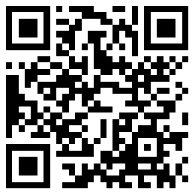
扫码文都四六级网，手机轻松复习备考

