2020年上半年大学英语四级写作：一张面具派对的海报
来源：文都教育
备考今年四六级的同学们要利用好复习时间，多做题，多总结，以期获得更高的分数。那么，短期之内想要让总分再次拔高，要从哪里寻求突破呢?答案应当是“写作”无疑!通常大家都会背诵一些作文模板句和常用素材，考场上再结合主题自己写一些，这样在作文上拿到的分数就会达到一个相对稳定的档次。想要在此基础上锦上添花，今天文都四六级和大大家分享2020年上半年大学英语四级写作：一张面具派对的海报，希望对您有所帮助。
英语四级写作：一张面具派对的海报
A Poster of a Masked Party
Under the auspices of the Student Union of our university, a well-prepared masked party will be held in the Students' Center at 7 o'clock p.m. on June, 5th.
You will certainly have a wonderful and colorful evening in our party.
Apart from dancing, you will enjoy many excellent performances made by our popular clubs on campus.
The roller-skating club, the hip-pop group and the like are on the list of our invitation.
Surprise and happiness are waiting for you!
It should be noted that smoking or drinking is forbidden in our party, and anyone with cigarettes or wine is not allowed in.
Besides, please don't forget to take a mask along with you, for it will bring you unexpected fun!
Welcome you and your friends to come and explore the unique and fantastic party.
以上为2020年上半年大学英语四级写作范文，再答四级写作的时候，考生们应该做到写作思路清晰明了，有层次，可以适当增加长难句和复杂句式，不要求全篇华丽词汇，希望本篇分析能给同学们的写作提供些许思路，祝同学们取得好成绩。
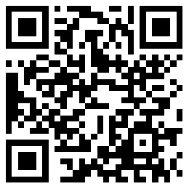
扫码文都四六级网，手机轻松复习备考

