2019考研英语(二)真题大作文：毕业生去向

来源：文都教育

2019考研英语于今日下午正式结束。不管各位同学发挥得如何，都请不要在所有考试结束前对答案，以免影响心情，进而影响到接下来的考试。文都考研英语辅导老师现将2019考研英语(二)真题大作文的参考范文及译文分享给大家，方便各位在考试结束后了解自己的写作情况。

【题目要求】
48.Directions:
Write an essay based on the following chart. In your essay, you should
1) interpret the chart, and
2) give your comments.
You should write about 150 words neatly on the ANSWER SHEET. (15 points)
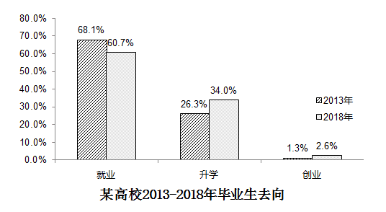

【参考范文】
This bar chart depicts the changes of college students’ different choices after graduation from 2013 to 2018. According to the data given above, the percentage of hunting for a job has decreased from 68.1% to 60.7% while the percentage of pursuing a further study in postgraduate schools increased from 26.3% to 34.0%. By contrast, the change of the percentage of starting a business is not obvious.
There are several possible factors which account for this phenomenon and the followings are the typical ones. On the one hand, due to the increasing emphasis on education, pursuing a further study has become much more popular for college students. On the other, it is the stress from fierce employment competition that makes college students realize the significance of enhancing their academic level and practical skills, which explains the reason why the percentage of hunting for a job has decreased obviously.
From what has been mentioned above, we can easily come to the conclusion that this established trend is acceptable. And it is wise for postgraduate students to broaden their horizons and to improve their practical skills during postgraduate study. Only in this way, can they be qualified for the future position.

【参考范文】
该柱状图描述了2013年至2018年间毕业大学生选择的变化。根据以上数据，找工作的比例从68.1%下降到了60.7%；选择继续深造的比例从26.3%上升到了34.0%。相比之下，创业的比例变化并不明显。
导致上述现象的原因可能有多个，但接下来我要说的是最为典型的两个。一方面，由于对教育的重视程度越来越高，继续深造已经成为越来越多的大学生的选择。另一方面，激烈的就业竞争压力使大学生意识到了提高学术水平和实践技能的重要性，这也就说明了为什么找工作的比例会明显下降。
综上所述，可以得出如下结论：上述所反映的既定趋势是可以接受的。但是，在读研期间拓宽视野并提高实践能力才是明智的。只有这样，他们才能胜任未来的工作。

以上就是文都考研英语辅导老师提供的2019考研英语(二)真题大作文的参考范文和相应译文，希望对大家的写作有所帮助，最后，祝大家取得理想的成绩！

